**1, The agg_methods dictionary defines how each column should be aggregated when grouping the data:**

* **first: Keep the first value (used for identifying metadata like names or periods).**
* **sum: Add up the values (e.g., total hours, amounts, super contributions).**
* **mean: Take the average value (used here for SG rate).**



**2. Group the payroll data**

**Groups the data by employee (Emp_Code) and period end date, then applies the aggregation rules defined in agg_methods. This produces one summary row per employee per period.**



**3. Sort the data for correct time series behaviour**

**Ensures the dataset is chronologically ordered within each employee, which is necessary for time-based operations like rolling sums or cumulative calculations.**

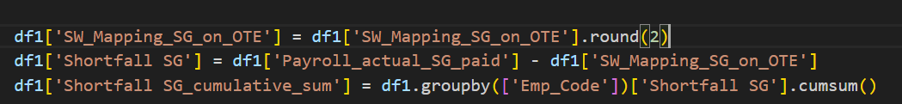

**4. Round mapped SG value  
Rounding the mapped super on OTE (Ordinary Time Earnings) to 2 decimal places ensures consistency and helps avoid false discrepancies due to float precision.**



**5. Calculate SG shortfall  
Calculates the difference between what was actually paid and what was expected (based on mapping).**

* **Positive = overpayment**
* **Negative = underpayment (a potential shortfall to be corrected)**



**6. Cumulative SG shortfall over time**

**Adds a running total of the shortfall for each employee over time.  
Helps understand ongoing over/underpayment trends and lays groundwork for applying offset logic later.**



**7. Final sort to ensure chronological order**

**Ensures the data remains properly sorted after new columns were added — crucial for rolling or lookback logic that depends on time order.**

**Column Descriptions:**

**cumulative_sum_12Months_OVERPAY**

**Description:**  
Total overpayments ("Shortfall SG" > 0.01) made in the 12 months leading up to and including the current row's Period_Ending_Date, per employee.  
Used to determine whether prior overpayments exist that could offset future shortfalls.

**Adjust_shortfall_Y/N**

**Description:**  
Indicates whether a negative shortfall (i.e. refund or reversal) can be adjusted using prior overpayments.

* 'Y': Eligible for adjustment (shortfall is negative and prior overpayments exist).
* 'N': Not eligible for adjustment.

**rolling_12M_adjustable_shortfall**

**Description:**  
Rolling sum of negative shortfalls (underpayments or reversals) over the past 12 months that are **eligible for adjustment** (Adjust_shortfall_Y/N = 'Y').  
Calculated per employee. Helps track the cumulative shortfall "used" against prior overpayments.

**Remaining_Adjustment_Balance**

**Description:**  
Represents the remaining "budget" or balance available to apply adjustments.  
= Overpayments in past 12 months + prior adjustable shortfalls  
Only calculated for rows where Adjust_shortfall_Y/N = 'Y'.

**Offset_Shortfall_Y/N**

**Description:**  
Indicates whether and how a negative shortfall should be offset using the available adjustment balance:

* 'Y': Fully offset (enough balance available)
* 'P': Partially offset (some balance available, but not enough)
* 'N': No offset (no balance or not eligible)

**Shortfall_Reduction**

**Description:**  
Amount of the shortfall that can be reduced (i.e. offset):

* If 'Y': Uses full shortfall value
* If 'P': Uses only available balance
* If 'N': No reduction (set to 0)

**Remaining_Shortfall_Balance**

**Description:**  
The portion of the shortfall still unpaid or unadjusted after any offsetting:

* If no balance is available or offset isn’t allowed → full shortfall remains
* If partial offset was allowed → remainder is shown
* If fully offset → 0

**One_Year_Prior**

**Description:**  
Reference date exactly 12 months prior to the current row’s Period_Ending_Date.  
Used to define the rolling 12-month window for overpayment and adjustment logic.